COM109 Coursework 2 – B00950166

MALAK ELABBASY

1. Introduction
The development of the Stress Less resources webpage was driven by both technical requirements and a strong emphasis on user-centred design. Before beginning implementation, I conducted a detailed review of the project specification to identify all functional and non-functional requirements. This ensured the final product would meet technical criteria while providing a meaningful, accessible experience for users.
Unlike typical web development projects, this website addresses a sensitive topic—stress management—requiring careful consideration of usability, accessibility, and emotional design. My approach combined technical implementation with psychological awareness, ensuring the website is not overwhelming, visually aggressive, or difficult to navigate.
The webpage was developed using HTML5, CSS3, JavaScript, and the jQuery library, with each technology playing a distinct role: HTML provides semantic structure, CSS ensures consistent and accessible styling, and JavaScript (with jQuery) enables dynamic interaction and real-time feedback.

2. Requirement Identification and Implementation
Following analysis of the project brief, several key requirements were identified:
- Use of client-side technologies (HTML, CSS, JavaScript, jQuery)
- Standards-compliant, well-structured code
- Implementation of dynamic and interactive features
- Application of UX/UI design principles
- Use of event-driven programming
- Inclusion of engaging and meaningful content
Rather than simply implementing these features, I ensured each requirement was fulfilled with clear intent and justification.

2.1 Client-Side Technologies
The website demonstrates comprehensive use of client-side technologies:
- HTML5 structures content using semantic elements such as <nav>, <header>, and <footer>, improving accessibility and maintainability.
- CSS3 creates a consistent design system across the page, including layout, typography, colour schemes, and responsive behaviour.
- JavaScript and jQuery implement interactivity, including accordions, event handling, and the mini-game.
For example, jQuery initialises accordion components efficiently:
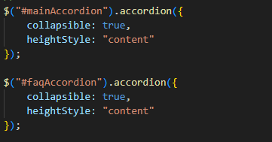
This demonstrates effective use of a framework to enhance functionality without unnecessary complexity.

2.2 Code Structure and Best Practices
The project follows best practices through a clear separation of concerns:
- Structure (HTML)
- Styling (CSS)
- Behaviour (JavaScript)
This modular approach ensures scalability and maintainability. Reusable CSS classes (e.g., .navbar__container, .footer__links) avoid redundancy and improve consistency. External stylesheets and scripts allow global updates without modifying individual elements, demonstrating efficient coding practice.

2.3 Event Handling and Interactivity
Event-driven programming plays a central role in the website's functionality:
- Click events (mini-game buttons)
- Scroll events (navigation button visibility)
- UI interactions (accordion expansion)
The scroll event enhances usability by dynamically responding to user behaviour:
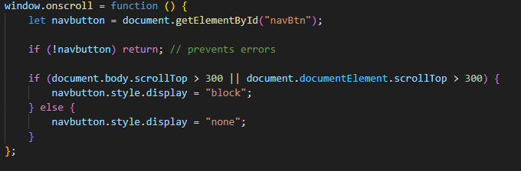This implementation uses the Browser Object Model (BOM) to access the window's scroll position and the Document Object Model (DOM) to manipulate the button's display property, creating a seamless user experience where navigation aids appear precisely when needed.

3. UX/UI Design Principles
A significant portion of this project focused on UX and UI design, particularly in preventing cognitive overload and promoting calm interaction.

3.1 Preventing Information Overload Through Progressive Disclosure
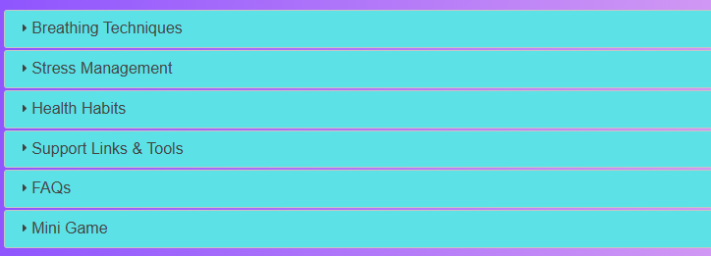
One of the most critical design decisions was implementing accordion components using jQuery UI. Rather than displaying all information simultaneously, content is segmented into expandable sections. This approach is rooted in cognitive load theory, first proposed by John Sweller, which states that the human brain has a limited capacity for processing information at any one time. When too much information is presented simultaneously, working memory becomes overloaded, leading to confusion, disengagement, and in the context of this website, potentially increased anxiety in users who are already struggling.
For a stress management platform, this risk is amplified. A user arriving at the page in a heightened state of stress or anxiety is far more vulnerable to feeling overwhelmed by dense, unstructured content. By hiding content behind expandable headers, the accordion system ensures users are only ever processing one topic at a time, significantly reducing this risk.
Justification:
- Reduces cognitive load by presenting information in digestible chunks
- Grants users control over their experience, fostering autonomy
- Improves readability and focus by eliminating visual clutter
- Prevents overwhelming users—particularly critical for stress-related content
The nested accordion structure in the FAQ section exemplifies progressive disclosure at multiple levels: users first see high-level categories, then expand to reveal specific questions, and finally access detailed answers. This hierarchical approach mirrors how users naturally seek information, reducing anxiety about navigating complex content. It also respects user autonomy, allowing individuals to engage only with topics relevant to their personal situation rather than being forced through irrelevant material.
The collapsible: true parameter is deliberately chosen to allow all sections to be closed simultaneously, giving users complete control rather than forcing one section to remain open. This small but meaningful decision reinforces the website's core philosophy: the user is always in control of their experience.
.
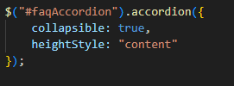
The collapsible: true parameter is deliberately chosen to allow all sections to be closed simultaneously, giving users complete control rather than forcing one section to remain open.

3.2 Colour Scheme and Emotional Design
The colour palette was carefully selected based on colour psychology principles:
background: linear-gradient(to right, #8c52ff, #e2a9f1, #5ce1e6);
Rationale:
Colour | Hex Code | Psychological Association
Purple | #8c52ff | Calmness, creativity, introspection
Pink | #e2a9f1 | Nurturing, compassion, emotional safety
Cyan | #5ce1e6 | Tranquillity, clarity, refreshment
Design Justification:
- Soft gradients create a calming visual effect, avoiding harsh transitions that could increase stress
- Pastel tones are associated with relaxation and clarity, deliberately avoiding high-saturation colours that may trigger anxiety
- The gradient direction (left to right) follows natural reading patterns in Western cultures, creating subconscious visual harmony
- Contrast ratios between text and backgrounds exceed WCAG 2.1 AA standards, ensuring legibility for users with visual impairments

3.3 Typography and Accessibility
The typography system prioritises accessibility and readability:
Sans-serif fonts were deliberately chosen for several accessibility reasons:
- Dyslexia-friendly: Sans-serif fonts reduce visual confusion caused by serifs, which can cause letters to appear to merge or flip for dyslexic readers
- Screen optimisation: Digital screens render sans-serif fonts more clearly at various sizes, reducing eye strain
- Cognitive load reduction: Clean letterforms require less processing effort, particularly important for users experiencing stress or anxiety
Line height and spacing were calculated to enhance readability:
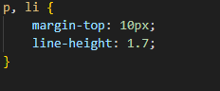
A line height of 1.7 exceeds the minimum 1.5 recommended by WCAG guidelines, providing additional breathing room that reduces the cramped appearance common on text-heavy pages. This spacing is particularly beneficial for users with attention difficulties or visual processing challenges.

4. Interactive Features: Technical and Conceptual Analysis

4.1 Mini-Game Implementation
The mini-game represents a deliberate therapeutic intervention disguised as simple entertainment. The implementation uses event-driven programming with precise timing control:
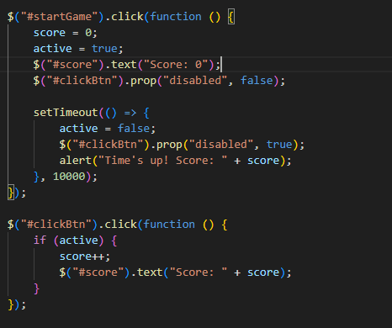

Technical Analysis:
- State management: The active boolean variable controls game state, preventing score manipulation outside the timed window
- DOM manipulation: jQuery's .text() method provides real-time feedback, updating the score display instantly
- Timer control: setTimeout() creates a precise 10-second window, using the BOM's timing capabilities
- Button state management: .prop("disabled", false/true) prevents user interaction outside valid game states, ensuring predictable behaviour
Psychological and Therapeutic Justification:
The game was intentionally designed with specific therapeutic properties grounded in established psychological research:
- Simplicity: The single-action mechanic requires minimal cognitive processing, making it accessible during high-stress states when complex decision-making becomes difficult. Research into stress-induced cognitive narrowing shows that anxiety reduces a person's capacity for multi-step thinking, meaning simple, single-focus tasks are far more effective as interventions than complex ones.
- Repetitive motion: Rhythmic clicking creates a grounding effect similar to techniques used in anxiety management, such as tapping or bilateral stimulation used in EMDR (Eye Movement Desensitisation and Reprocessing) therapy. Bilateral and repetitive physical stimulation has been shown to engage the parasympathetic nervous system, actively countering the fight-or-flight response triggered by stress.
- Short duration: The 10-second timeframe is deliberately brief—long enough to shift attention away from stressors but short enough to prevent new anxiety about performance or time commitment. This respects the psychological principle that brief, achievable tasks build self-efficacy, a person's belief in their own ability to cope, which is directly linked to stress resilience.
- Immediate feedback: The real-time score counter provides instant gratification and a measurable sense of accomplishment. This triggers a small dopamine release, a neurotransmitter associated with reward and motivation, which can temporarily elevate mood and break a negative stress cycle.
- Clear boundaries: Defined start and end points create psychological safety. Users know exactly what to expect and when the task will conclude, removing uncertainty, which is itself a primary driver of anxiety. The disabled button state outside of active gameplay reinforces these boundaries at a technical level, ensuring the experience remains predictable and controlled.
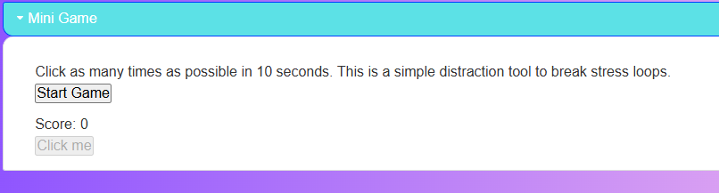

4.2 Back-to-Top Navigation Button
The navigation button demonstrates sophisticated UX thinking combined with technical implementation:
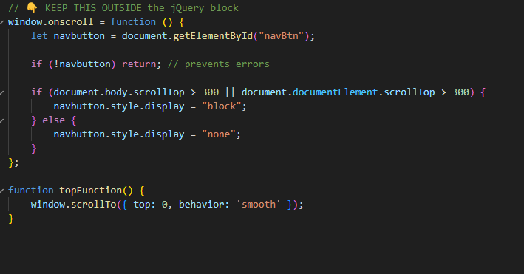

Technical Features:
- Cross-browser compatibility: The condition checks both document.body.scrollTop and document.documentElement.scrollTop to ensure functionality across different browsers
- Null check: if (!navbutton) return prevents JavaScript errors if the element is missing
- Smooth scrolling: The behavior: 'smooth' parameter creates an animated transition rather than jarring instant movement
UX Justification:
- Contextual appearance: The button only appears after scrolling 300 pixels, preventing visual clutter when unnecessary
- Reduced physical effort: Long pages require significant scrolling; the button eliminates this repetitive strain
- Visual feedback: CSS transitions provide hover effects that confirm interactivity

5. External Resources and Support Links
The inclusion of external mental health resources was a deliberate design decision that significantly enhances the website's value proposition.

5.1 Professional Support Services
Links to Samaritans and Mind serve multiple purposes:
- Extended support: The website acknowledges its limitations as a self-help resource, directing users to professional services when needed
- Credibility: Association with established organisations increases user trust
- Ethical responsibility: For sensitive topics like mental health, providing professional referrals is essential

5.2 Distraction Tools
The external game links (Snake, Tetris, Quick Draw) complement the internal mini-game:
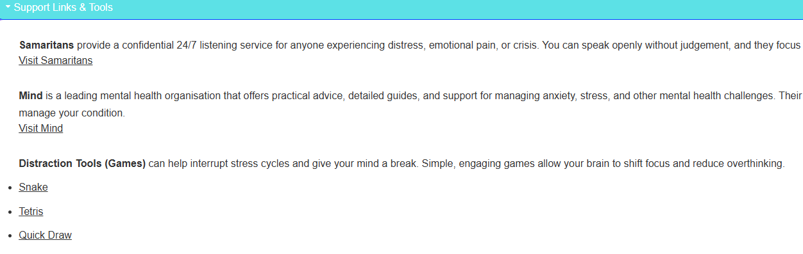
- Variety: Different game types suit different preferences and stress responses. Snake demands sustained focus, Tetris requires pattern recognition, and Quick Draw engages creativity — meaning users with different coping styles are more likely to find something that works for them.
- Extended engagement: External games offer longer distraction periods when needed. While the internal mini-game provides a brief 10-second intervention, some users may require more sustained relief to fully break a stress cycle, making these external options a valuable extension of the toolkit.
- Evidence-based selection: Research suggests puzzle games like Tetris can reduce intrusive thoughts and anxiety symptoms. This is because Tetris occupies the brain's visuospatial processing system — the same system responsible for generating anxious mental imagery — effectively crowding out negative thought patterns and providing targeted rather than simply general distraction.

6. Responsive Design and Mobile Accessibility
The CSS implements responsive behaviour through media queries:
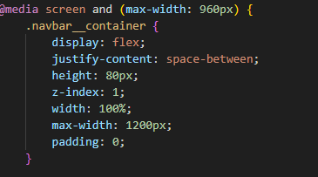
@media screen and (max-width: 960px) {
.navbar__menu {
display: grid;
grid-template-columns: auto;
position: absolute;
top: -1000px;
opacity: 0;
transition: all 0.5s ease;
}
}
The hamburger menu transformation ensures navigation remains accessible on mobile devices, where a significant portion of users experiencing acute stress may access resources. The smooth transition animations maintain the calming aesthetic even during interface changes.

7. Conclusion
The Stress Less resources webpage successfully meets all specified requirements while demonstrating strong application of UX/UI design principles. The integration of interactive elements, accessible design, and thoughtful content organisation results in a highly functional and user-friendly website.
The project highlights the importance of balancing technical implementation with user needs, particularly when designing for sensitive topics such as mental health. Every design decision—from colour selection to game mechanics to typography—was informed by both technical best practices and psychological understanding of the target audience.
The combination of progressive disclosure through accordions, therapeutic micro-interactions through the mini-game, and comprehensive external resource integration creates a holistic stress management platform that extends beyond simple information delivery to actively support user wellbeing.

8. References
W3Schools How to create a responsive top navigation menu. Available at: https://www.w3schools.com/howto/howto_js_topnav_responsive.asp (Accessed: 22 April 2026).
jQuery UI Accordion widget. Available at: https://jqueryui.com/accordion/ (Accessed: 22 April 2026).
W3Schools How to create a scroll back to top button. Available at: https://www.w3schools.com/howto/howto_js_scroll_to_top.asp (Accessed: 22 April 2026).
Lidor Systems Nested accordions in jQuery and how to create them. Available at: https://www.lidorsystems.com/support/articles/jquery/accordion/nested-accordions.aspx (Accessed: 22 April 2026).

